GE04 – Introduction to Programming Technical Developer Document (Python)
Table of Contents
1. Python Development Environment and Fundamentals 1
Installing Python and Checking the Python Version 1
Setting Up Python in Visual Studio Code (VS Code) 1
Creating, Saving, and Running Python Programs 1
Debugging Python Programs: Setting Breakpoints and Stepping Through Code 1
2. Introduction to Programming 1
Variables, Assign into Memory and Naming Conventions 1
Functions, Arguments, and Return Values 1
Strings and Formatted Output Using f-Strings 1
Data Types and Type Conversion 1
Comments 1
Reading User Input and Displaying Output 1
3. Selection Structures and Decisions 1
Boolean Expressions and Relational Operators and Comparisons 1
Flow of Control Decisions and Branching 1
One-Way Selection: if and Two-Way Selection: if/else 1
Multiway Selection: if/elif/else 1
Nested Selection Structures 1
Logical Operators and Selections 1
Logical Operators and Selections 1
Selection Labs: Algorithms, Testing, and Debugging 1
L18 Lab 1: Free Shipping Eligibility 1
L18 Lab 2: Problem Solving: Secure Building Access 1
4. Loops and Lists - Control Flow 1
Conditional execution: if / elif / else 1
while loops 1
for loops 1
8.4 break, continue, and input validation 1
5. Functions (Optional) 1
Returning values 1
Scope 1

1. Python Development Environment and Fundamentals
Python runs your code; VS Code is the editor where you write, run and debug it. Both must be installed and linked together.

Installing Python and Checking the Python Version
- Download the installer from python.org/downloads and run it.
- On Windows, tick Add python.exe to PATH before clicking Install. This lets the terminal find Python.
- Open a terminal and check the version:
python --version
On macOS or Linux use python3 --version. On Windows, py --version also works. A reply such as Python 3.12.x means the install worked.

Setting Up Python in Visual Studio Code (VS Code)
- Install VS Code from code.visualstudio.com.
- Open the Extensions panel (Ctrl+Shift+X), search for Python (published by Microsoft), and click Install.
- Press Ctrl+Shift+P, type Python: Select Interpreter, and pick the Python version you installed. The chosen version shows in the bottom-right status bar.
- Open a project folder with File > Open Folder so all your files live in one place.

Creating, Saving, and Running Python Programs
- Create a file with File > New File and save it as hello.py (Ctrl+S). The .py ending tells VS Code it is Python.
- Type a program:
print("Hello, world!")
- Run it with the Run Python File play button (top right), or in the terminal (Ctrl+`):
python hello.py
The output appears in the terminal panel.

Debugging Python Programs: Setting Breakpoints and Stepping Through Code
A debugger pauses your program so you can watch it run one line at a time and find mistakes.
- Breakpoint: click in the margin left of a line number. A red dot appears, and the program will pause there.
- Start debugging: press F5 and choose Python File.
- Step controls (while paused):
Action | Key | What it does
Step Over | F10 | Run the current line, skip inside any function it calls
Step Into | F11 | Enter the function being called on this line
Step Out | Shift+F11 | Finish the current function and return to the caller
Continue | F5 | Run until the next breakpoint
- Variables panel: shows each variable's current value as you step. If a value is not what you expected, the bug is at or just before this line.

2. Introduction to Programming
A program stores data in variables, reuses steps in functions, and talks to the user through input and output.

Variables, Assign into Memory and Naming Conventions
A variable is a name that points to a value stored in memory. The = sign assigns the value on the right to the name on the left.
age = 20
first_name = "Ada"
Naming rules and conventions:
- Use letters, digits and underscores; never start with a digit.
- Names are case-sensitive: score and Score are different variables.
- Use snake_case (lowercase words joined by underscores), such as total_price.
- Pick descriptive names, and avoid Python keywords such as if, for and print.

Functions, Arguments, and Return Values
A function is a named block of code you can run again and again. Arguments are the values you pass in; the return value is what the function hands back.
def add(a, b): # a and b are parameters
return a + b # sends the result back

total = add(2, 3) # 2 and 3 are arguments; total is 5
A function with no return gives back None.

Strings and Formatted Output Using f-Strings
A string is text inside quotes. An f-string starts with f and inserts variables inside {}.
name = "Ada"
score = 92.456
print(f"{name} scored {score:.1f}") # Ada scored 92.5
The :.1f part rounds a number to one decimal place.

Data Types and Type Conversion
Type | Meaning | Example
int | Whole number | 7
float | Decimal number | 3.14
str | Text | "hello"
bool | True or False | True
Check a type with type(x). Convert between types with int(), float() and str():
int("5") # 5
float(3) # 3.0
str(42) # "42"
Converting text that is not a number, such as int("abc"), causes a ValueError.

Comments
Comments are notes for humans; Python ignores them. Start one with #.
# Calculate the area
area = width * height # width times height
Explain why code does something, not just what it does.

Reading User Input and Displaying Output
input() pauses the program and returns what the user types, always as a string. print() shows output.
name = input("What is your name? ")
age = int(input("How old are you? ")) # convert text to a number
print(f"Hello, {name}. Next year you will be {age + 1}.")

3. Selection Structures and Decisions
Selection lets a program choose which code to run based on whether a condition is true or false.

Boolean Expressions and Relational Operators and Comparisons
A Boolean expression evaluates to True or False. Relational operators compare two values:
Operator | Meaning | Example | Result
== | Equal to | 5 == 5 | True
!= | Not equal to | 5 != 3 | True
< | Less than | 2 < 1 | False
> | Greater than | 4 > 1 | True
<= | Less than or equal | 3 <= 3 | True
>= | Greater than or equal | 2 >= 5 | False
Common mistake: = assigns a value, while == compares two values.

Flow of Control Decisions and Branching
By default Python runs lines top to bottom. A decision creates a branch: the program takes one path or another depending on a condition. Python uses a colon : and indentation (4 spaces) to mark which lines belong to a branch.

One-Way Selection: if and Two-Way Selection: if/else
One-way: run the block only when the condition is true; otherwise do nothing.
if temperature > 85:
print("It's hot.")
Two-way: pick one of two blocks.
if age >= 18:
print("Adult")
else:
print("Minor")

Multiway Selection: if/elif/else
Use elif ("else if") to test several conditions in order. Python runs the first block whose condition is true and skips the rest.
if score >= 90:
grade = "A"
elif score >= 80:
grade = "B"
elif score >= 70:
grade = "C"
else:
grade = "F"

Nested Selection Structures
An if placed inside another if is nested. The inner check runs only if the outer one is true. Indent each level 4 more spaces.
if has_ticket:
if age >= 18:
print("Enter")
else:
print("Adults only")
else:
print("Buy a ticket")

Logical Operators and Selections
Logical operators combine conditions into one.
Operator | True when | Example
and | Both sides are true | age >= 18 and has_id
or | At least one side is true | day == "Sat" or day == "Sun"
not | Flips True to False | not is_raining
if age >= 18 and has_id:
print("Allowed")
Combining conditions with and/or often replaces a nested if with a flatter, easier-to-read one.

Logical Operators and Selections

Selection Labs: Algorithms, Testing, and Debugging
- Designing Algorithms Using Pseudocode
- Implement a few lines of code and test

L18 Lab 1: Free Shipping Eligibility
User Story: As an online shopper, I want to know whether my order qualifies for free shipping so that I can understand whether I will need to pay a shipping fee.
Acceptance Criteria
- The program asks the user to enter their order total.
- If the order total is $50 or more, display "You qualify for free shipping."
- Otherwise, display "Shipping fee required."

Your Task
- Create test cases covering all combinations
- Write pseudocode on paper showing what you think will be the best if/else approach
- Implement the program in Python and test
- Use the debugger to observe

Test Cases:
Pre-condition | Post Condition
Order is <$50 | Shipping fee required
Order is >$50 | You qualify for free shipping
Order = $50 | You qualify for free shipping
Order = $0 | Shipping fee required
Order = $49.99 | Shipping free required
Order = $50.01 | You qualify for free shipping

Paste the image of the Pseudocode for the Algorithm you wrote on paper
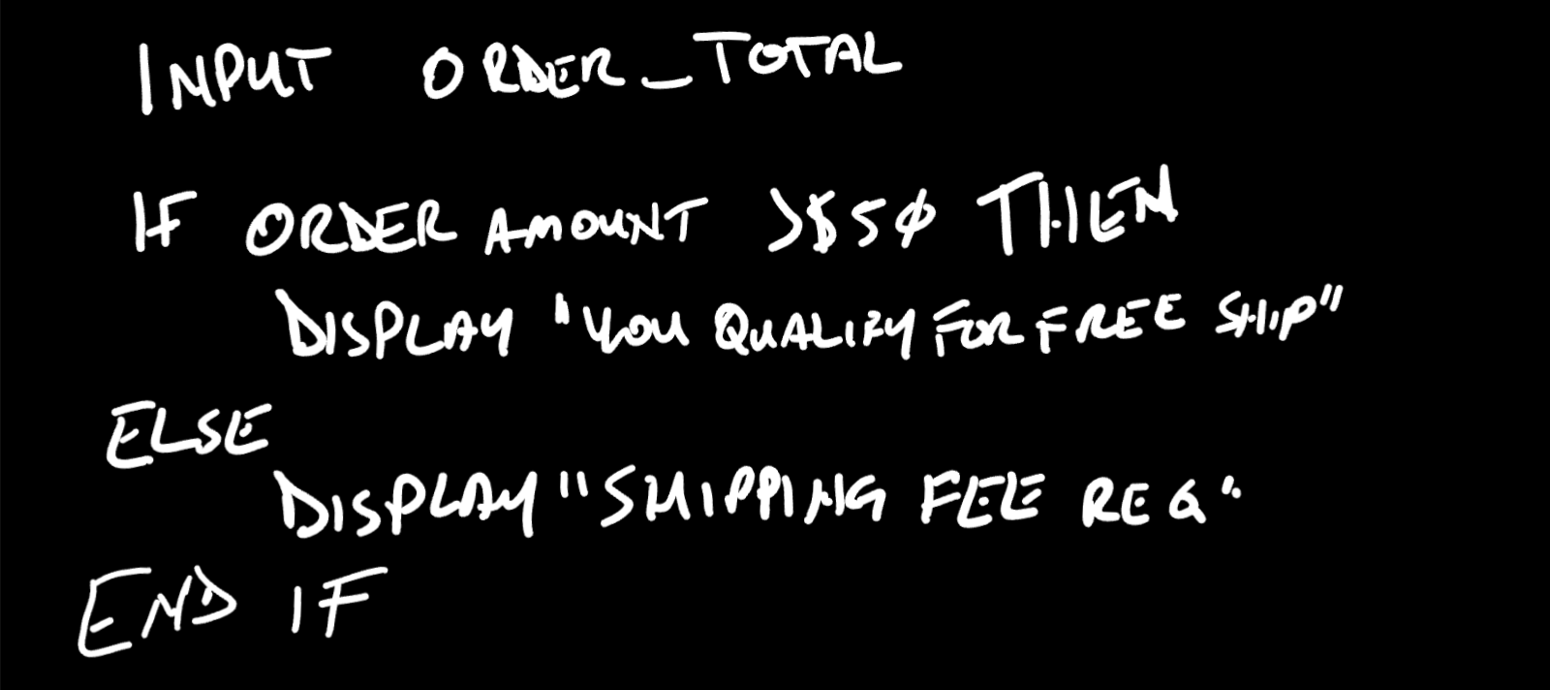

Actual Code:
while True:
#this is a loop
#it only lets the user continue once True,
#so a ValueError would cause a repeat prompt
try:
price = float(input("Please enter the total of your order: ").replace("$", ""))
break
except ValueError:
#There are more error types that allow programmers
#to stack several except blocks, one per error type
print("Please enter a valid number like 49.99, not letters.")
if price >= 50:
print ("You qualify for free shipping!")
elif price <0:
print("Oh, so we owe YOU money? Ain't that about a...")
else:
print("Shipping fee required.")

My original code was a lot simpler. After consulting with AI, I learned about how to cover edge cases like when someone uses a string in an input that expects an integer, then how to ‘replace’ characters in input (removing the $), then creating a loop, and what it is to set a condition to break a loop. The end result was several back and forths later.

L18 Lab 2: Problem Solving: Secure Building Access
Requirements: User Story: As a building security administrator, I want a system that checks a person's access card before checking their PIN so that only authorized individuals can enter the building.
Acceptance Criteria
- The program uses two Boolean variables: card_valid and pin_correct.
- If the access card is invalid, display "Invalid access card".
- If the access card is valid, display "Access card accepted".
- Only when the card is valid should the program check whether the PIN is correct.
- If the PIN is correct, display "Access granted".
- Otherwise, display "Incorrect PIN".

Your Tasks
- Create test cases covering all combinations
- Write pseudocode on paper showing what you think will be the best if/else approach
- Implement the program in Python.
- Use the debugger to observe
- Explain why the PIN condition is not evaluated when the access card is invalid.

Test Cases:

Pre-condition | Post Condition
Invalid card/Valid PIN | Print query False message, break
Valid card/Invalid PIN | Print PIN check False message, break
Invalid card/Invalid PIN | Print query False message, break
Valid card/Valid PIN | Print query True message, access granted

Paste the image of the Pseudocode for the Algorithm you wrote on paper
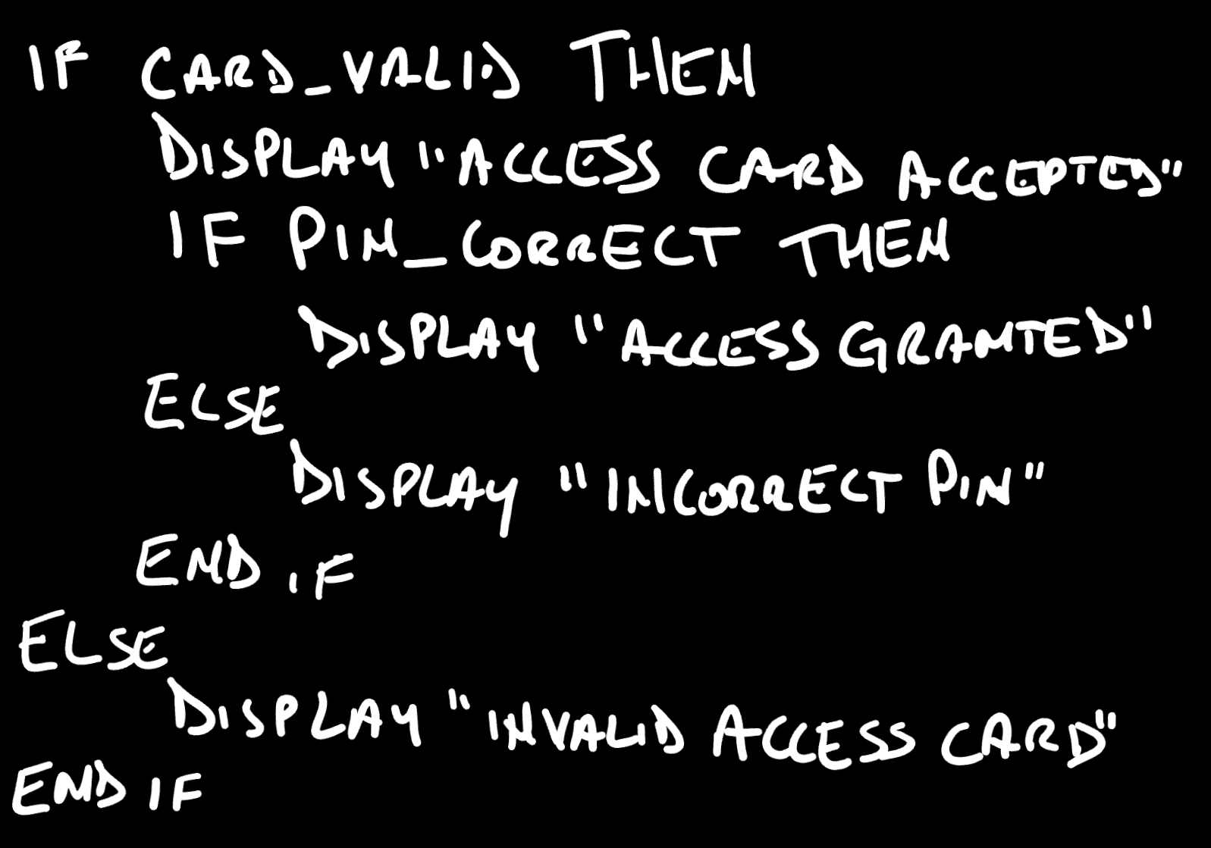
Is card valid? > No > print denial
Yes > Begin PIN check > PIN check valid? > No > Print denial
Yes > Print confirmation > Access granted

Actual Code:
door_unlock = False

def access_granted():
global door_unlock
"""'global' affects variables at the top of the file
and triple quotes can initiate comments like a # can"""
door_unlock = True
print("Congratulations! Access granted”)

swiped = input("Please swipe your access card (User1 or User2): ")
card_valid = (swiped == "User1")
card_invalid = (swiped == "User2")
if card_valid:
pin = input("Access Card Accepted! Please enter PIN (User1 or User2): ")
pin_correct = (pin =="User1")
if pin_correct:
access_granted()
print(door_unlock)
else:
print("Sorry, sucka! Incorrect PIN.")
elif card_invalid:
print("Away, beast! Invalid access card!")
else:
print("That's a credit card, you fool!")

The pin condition is not checked if the card is invalid because a False/card_invalid prevents the run from continuing down the card_valid path.

4. Loops and Lists - Control Flow

Conditional execution: if / elif / else
End each condition line with a colon and indent the block beneath it. Python checks the conditions from top to bottom and runs only the first block that is true.
score = 85

if score >= 90:
print("A")
elif score >= 80:
print("B")
elif score >= 70:
print("C")
else:
print("Below C")
Output
B

while loops
A while loop repeats as long as its condition is true. Make sure something inside the loop eventually makes the condition false, or you will create an infinite loop (press Ctrl+C to stop one).
countdown = 3
while countdown > 0:
print(countdown)
countdown -= 1
print("Liftoff!")
Output
3
2
1
Liftoff!

for loops
A for loop walks through the items of any sequence (a list, string, range, dictionary, and so on). range(stop) counts from 0 up to but not including stop; range(start, stop, step) gives more control.
for n in range(3):
print(n) # 0, 1, 2

print(list(range(2, 10, 3))) # start, stop, step

for letter in "cat":
print(letter)

total = 0 # the "accumulator" pattern
for n in [10, 20, 30]:
total += n
print("Total:", total)
Output
0
1
2
[2, 5, 8]
c
a
t
Total: 60

break, continue, and input validation
break leaves a loop immediately; continue skips to the next pass. A pattern I like is to keep asking until the user gives valid input instead of just quitting (but this can cause loops if implemented incorrectly!):
while True:
answer = input("Enter a positive whole number: ")
if answer.isdigit() and int(answer) > 0:
break
print("That wasn't valid, try again.")

print("You entered", int(answer))
Output
Enter a positive whole number: abc
That wasn't valid, try again.
Enter a positive whole number: -5
That wasn't valid, try again.
Enter a positive whole number: 7
You entered 7

5. Functions (Optional)
A function is a named, reusable block of code. Define it with def, give it parameters (inputs), and send a result back with return. The values you pass in when you call it are called arguments.
def greet(name, greeting="Hello"):
"""Return a greeting for the given name."""
return f"{greeting}, {name}!"

print(greet("Sam")) # uses the default greeting
print(greet("Sam", greeting="Welcome")) # keyword argument
Output
Hello, Sam!
Welcome, Sam!

Returning values
def min_max(values):
return min(values), max(values) # returns a tuple of two values

low, high = min_max([3, 9, 1])
print(low, high)

def show(x):
print(x) # prints, returns nothing

result = show(5)
print(result) # a function with no return gives None
Output
1 9
5
None
Note: print vs. return: print() only displays something on the screen. return hands a value back to the code that called the function so it can be stored or reused.

Scope
A variable created inside a function is local – it exists only while the function runs. Assigning to a name inside a function does not change a variable of the same name outside it.
total = 100

def change():
total = 5 # a brand-new LOCAL variable
print("inside:", total)

change()
print("outside:", total)
Output
inside: 5
outside: 100

